Guidelines for P1

# Pictures

1. Circuits must be made with either PLECS or ALTIUM
   1. For control and overview of component placement use PLECS
   2. For detailed circuits use ALTIUM
2. To insert the pictures in the report, use the P1 folder under pictures.
   1. Create a relevant subfolder for specific stuff
3. Latex example:

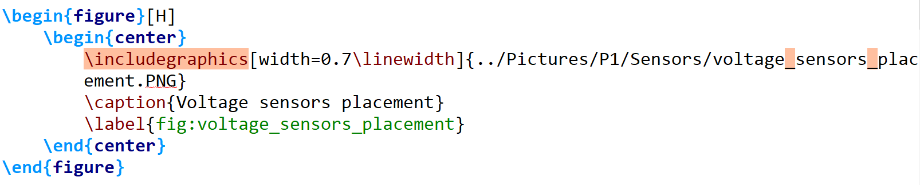

1. Try to create your own graphs if possible
2. If not remember to reference your shit!!

# GIT

1. Rule #1 of GIT: DO NOT COMMIT SOMETHING WHICH CANNOT COMPILE!!!
   1. If you can’t compile the document and want to commit, comment the input with the file in fault.
2. If multiple persons work in the same file, you are not having enough subdocuments
   1. This should only happen with bibliography file. Try to coordinate with the others about editing it.
   2. Before you edit the bibliography file you should pull the latest changes in GIT. Push the change when you are done.
3. Rule #2 of GIT: GIT is always open.

# LATEX

1. If you add a package to the preamble insert where it makes sense. Remember to add a comment with a description of the content
2. Use the command \todo{…} to create a note for what should be done later.
   1. This will create a note at the place of interest but also show in a list in the beginning, so please do this.
   2. Two examples:



# Other nice stuff

1. When you have written something, get another person to read it
2. Wikipedia is okay for understanding, but freaking bad for references.